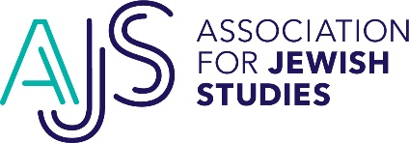

2024 - 2025 AJS Dissertation Completion Fellowship Competition
Confidential Institutional Progress Time to Degree Confirmation Form

Deadline for Submission: November 15, 2023

Applicant Name:

Contact Information for Department Chair or Director of Graduate Studies

Name:

Academic Institution:

Department/Office:

Title:

E-mail:

Phone Number:

The above graduate student is applying for a Dissertation Completion Fellowship from the Association for Jewish Studies. This fellowship will provide up to $33,000 to support completion of the dissertation in the 2024 - 2025 academic year. It is imperative that recipients of this fellowship complete their dissertations by the end of the fellowship year (by June 30, 2025). We thus ask an institutional official to confirm the following information regarding the applicant. Please write “yes” or “no” in each space to confirm the information:

_______ The applicant is ABD (all requirements for the degree have been completed except for the dissertation).

_______ The applicant’s timeline for successful defense of the dissertation by June 30, 2025 is feasible.

_______ Should the applicant receive a Dissertation Completion Fellowship for the 2024 – 2025 academic year, the department guarantees that it will not provide the applicant with any doctoral aid in subsequent years.

______________________________________
Name (print)

______________________________________
Signature

_______________________________________
Date

Once you have completed this form, please save and upload it as a PDF document in the link provided in the e-mail you received from the applicant via Interfolio, the online application system used by the AJS. Questions? Please contact Amy Weiss, AJS Senior Grants and Professional Development Manager, at aweiss@associationforjewishstudies.org.

